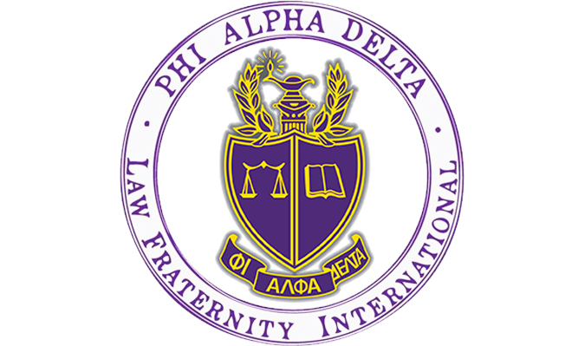

Are you thinking about going into law? Want to help your community and learn what it’s like to be a dedicated attorney?
Phi Alpha Delta is the place for you!
PAD is a co-ed Pre-Law organization for the lawyers of the future.

- Weekly Tuesday Talks from lawyers, law schools, and judges across the country, sponsored by the University of Colorado Boulder Pre-Law Office!
- Local fundraisers with your favorite restaurants!
- Philanthropies to help your community through local organizations!
- A chance to go to Washington, D.C. for FREE with fellow PAD members. Attend our Annual Pre-Law Fair October 21, 2019 with over 100 law schools participating.
- Exclusive discounts to LSAT Prep Courses!
- 3rd in the nation among recruiting chapters with 109 members in 2016!

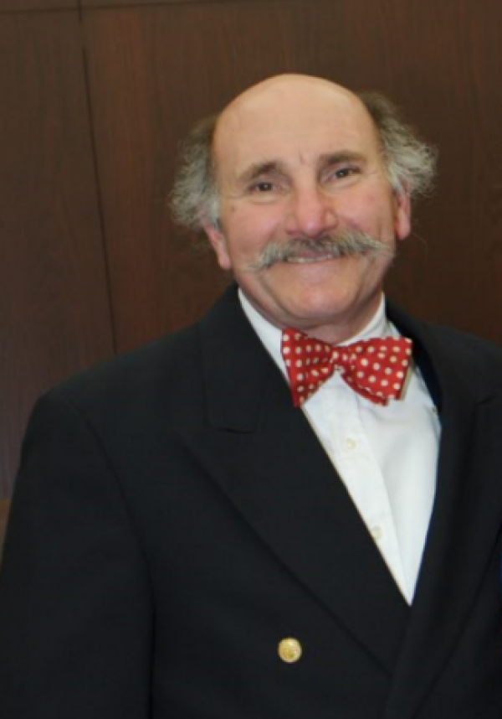
Co-sponsored by the
CU Boulder Pre-Law Office:

Anthony Bastone
Pre-Law Academic Advisor
Phi Alpha Delta Faculty Advisor
http://www.colorado.edu/advising/pre-law
Center for Community, Room S454
Tel: 303-492-3474 (direct)
303-492-6541 (office)
Email: anthony.bastone@colorado.edu

Tuesday Talks Speaker Schedule
Fall 2019

All events held at 5:30 PM in Wolf Law Room 207

9/3/19 – Sandra Jones PhD – Dean of Students – CU Boulder
9/10/19 – Kristine Jackson – Assistant Dean for Admissions & Financial Aid – CU Law
9/17/19 – Sarah Arslanian – Manager Prelaw Services – Access Lex – Westchester, PA
10/1/19 – Conor Crawford – Associate Attorney – Ballard Spahr – Denver/Boulder, CO
10/8/19 – Valerie Simons – Associate Vice Chancellor & Title 1X Coordinator

10/15/19 – Alice Norman – Chief Public Defender – Denver Municipal Court – Denver, CO

10/22/19 – Capstone Speaker -Alissa Leonard – Assistant Dean for Admissions & Financial Aid – Boston University School of Law – Boston MA
10/29/19 – Kathy Sulentic – Attorney and Associate Director of Enforcement NCAA – Chairperson of Enforcement Staff’s Integrity Unit – Indianapolis, IN
11/5/19 – Eric Neusch, Solo Practice – Denver Colorado

11/12/19– Tracy Warren – Assistant Dean for Admissions – University of Nebraska College of Law – Lincoln, NE
11/19/19 – Danae McElroy – Director of Admissions – UCLA Law School, Los Angeles
12/10/19 – Mathiew Le – Assistant Dean of Admissions & Financial Aid – University of Texas School of Law – Austin, TX

Questions about Phi Alpha Delta or the Pre-Law Office? Contact us:
Dean Anthony Bastone (Pre-Law Academic Advisor): anthony.bastone@colorado.edu
Berkley Newhouse -Velie (Phi Alpha Delta President):
berkeley.newhousevelie@colorado.edu
(Phi Alpha Delta Treasurer): aubrie.bailie@colorado.edu
(Amanda Rios-Santiago Secretary): amanda.riossantiago@colorado.edu

