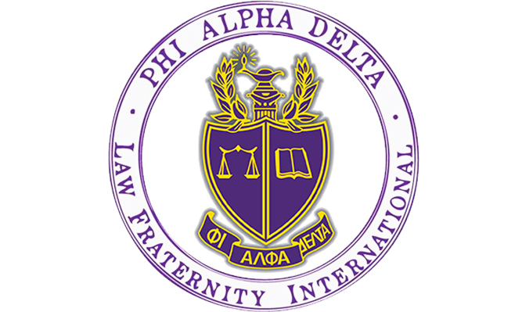

Are you thinking about going to law school? Do you want to help your community and learn how to be a dedicated attorney?

Phi Alpha Delta is the place for you!

What is PAD? PAD is a co-ed Pre-Law organization for the lawyers of the future. Our chapter at the University of Colorado Boulder is ranked number three in the nation among recruiting chapters. The Tuesday Talks Program was also named the top professional law program in the country by Phi Alpha Delta International in 2021!

What do members of PAD do?

- Attend weekly Tuesday Talks from attorneys, law school admission deans and directors, and judges across the country, sponsored by the University of Colorado Boulder Pre-Law Office!
- Participate in local fundraisers with your favorite restaurants!
- Engage with philanthropies to help your community through local organizations!
- Get a chance to go to Washington, D.C. for free with fellow PAD members. Attend our Annual Pre-Law Fair each fall with over 100 law schools participating.
- Receive exclusive discounts to LSAT Prep Courses!

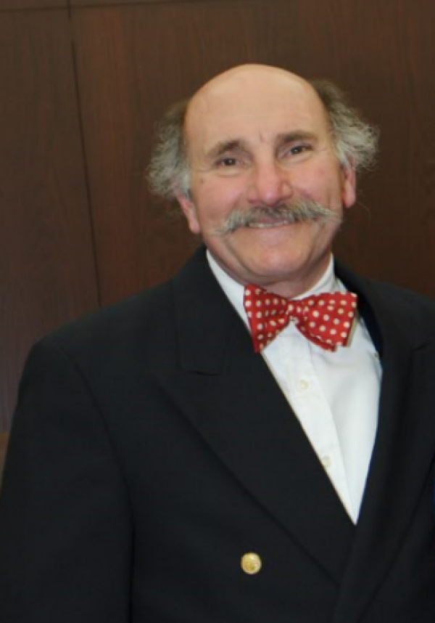
Let’s Get in Touch!

PAD is co-sponsored by the CU Boulder Pre-Law Office.

Anthony Bastone
Program Manager
Academic Advisor/Prelaw
Phi Alpha Delta Faculty Advisor

Phone: 303-492-3474 (direct)
303-492-6541 (office)
Email: anthony.bastone@colorado.edu

Website: http://www.colorado.edu/advising/pre-law
Office: Center for Community, Room S440
Tuesday Talks Speaker Schedule | Spring 2022

Tuesday Date | Guest Speaker
January 11, 2022 | Director Admissions Peter Eraca | UC Irvine School of Law  Amy Beier Best Director Admissions | University of Iowa College of Law  Kathryn Espiritu | Fordham Law School  Kimberlee Gardner Director Admissions Financial Aid & Strategic Recruitment | Boston College Law School
January 18, 2022 | Mathiew Le Assistant Dean Admissions & Financial Aid | University of Texas at Austin School of Law
January 25, 2022 | Rebecca Scheller Associate Dean for Admissions & Financial Aid – University of Wisconsin Law School
February 1, 2022 | Associate Dean Renee Post, Admissions & Financial Aid & Randi Garnick, Director of Admissions |University of Pennsylvania Carey Law School
February 15, 2022 | Associate Dean Reyes Aguilar, Admissions & Financial Aid| University of Utah S. J. Quinney College of Law
February 22, 2022 | Bobby Rosenbloum Shareholder Greenberg Traurig | Chairman Global Entertainment & Media Practice [Atlanta, Georgia]
March 1, 2022 | Phyllis Wan, Chief Diversity & Inclusion Officer | Holland & Hart [Denver, Colorado]
March 8, 2022 | Lindsey Wyrick | Liability Defense & Commercial Litigation, Cobb Martinez [Dallas, Texas]
March 15, 2022 | Professor Melanie Kay & Amy Bauer Dean & Professor of Law |Co-Directors Master of Studies in Law in Ethics & Compliance| University of Colorado Law School
March 29, 2022 | Kristen Fletcher – Faculty Associate-Research | Energy Academic Group | Naval Post Graduate School – (NPS) | Monterey, California
April 12, 2022 | TBD
April 19, 2022 | Travis Tygart, ESQ, Chief Executive Officer |US Anti-Doping Agency – Colorado Springs, Colorado
April 26, 2022 | Kristi Jobson, Assistant Dean for Admissions & Chief Admissions Officer | Harvard Law School | Cambridge Massachusetts

How do I join Tuesday Talks?
- Recurring Link: https://cuboulder.zoom.us/j/99742846893
- Time: All Tuesday Talks will begin 5:30pm MST via Zoom

Contact us!
Dean Anthony Bastone | Program Manager and Academic Advisor for Pre-Law
Email: anthony.bastone@colorado.edu

Sarah Rosenbloum | Phi Alpha Delta President
Email: Sarah.rosenbloum@colorado.edu

Stephanie Morita | Phi Alpha Delta Vice President
Email: stephanie.morita@colorado.edu

Jenna Goldstein | Phi Alpha Delta Secretary
Email: jenna.goldstein@colorado.edu

Sophia Duax | Phi Alpha Delta Treasurer
Email: Sophia.Duax@colorado.edu

