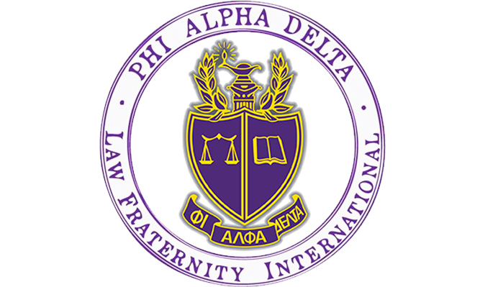

Are you thinking about going to law school? Do you want to help your community and learn how to be a dedicated attorney?

Phi Alpha Delta is the place for you!

What is PAD? PAD is a co-ed Pre-Law organization for the lawyers of the future. Our chapter at the University of Colorado Boulder is ranked number three in the nation among recruiting chapters. The Tuesday Talks Program was also named the top professional law program in the country by Phi Alpha Delta International in 2021!

What do members of PAD do?

- Attend weekly Nationally Acclaimed Tuesday Talks Program – presentations from attorneys, law school admission deans and directors, and judges across the country, sponsored by the University of Colorado Boulder Pre-Law Office and Phi Alpha Delta.
- Participate in local fundraisers with your favorite restaurants!
- Engage with philanthropies to help your community through local organizations!
- Get a chance to go to Washington, D.C. for free with fellow PAD members. Attend our Annual Pre-Law Fair each fall with over 100 law schools participating.
- Receive exclusive discounts to LSAT Prep Courses!

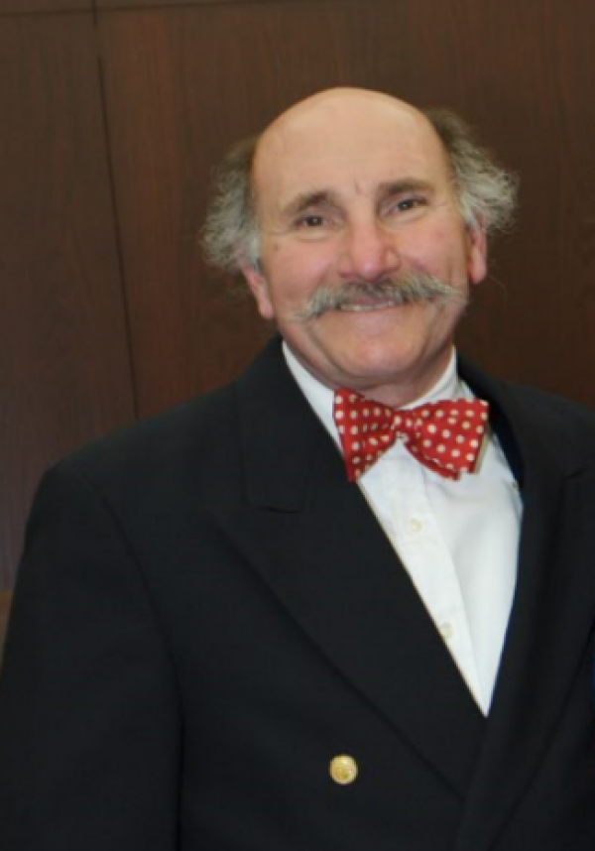
Let’s Get in Touch!

PAD is co-sponsored by the CU Boulder Pre-Law Office.

Anthony Bastone
Program Manager
Academic Advisor/Prelaw
Phi Alpha Delta Faculty Advisor

Phone: 303- 775-6321

Email: anthony.bastone@colorado.edu

Website: http://www.colorado.edu/advising/pre-law

Office: Center for Community, Room S440
Tuesday Talks Speaker Schedule | Fall 2022

Tuesday Date | Guest Speaker/Speakers
August 23/2022 | Alexander Harrison, Esq. – Assistant District Attorney – Santa Barbara, California
August 30/2022 | Peter Eraca – Director of Admissions – UC Irvine School of Law- Kimberlee Gardner – Director of Admissions – Boston College Law School – Amy Best – Director of Admissions – University of Iowa School of Law & Kathryn Espiritu – Director of Admissions – Fordham University School of Law
September 6/2022 | Mimi Huang – Assistant Dean of Admissions – Lewis & Clark Law School – Portland, Oregon
September 20/2022 | Natalie Blazer – Assistant Dean of Admissions – University of Virginia School of Law
September 27/2022 | Sarah Keiski – Assistant Dean of Admissions – University of Oregon School of Law
October 4/2022 | Sarah Zearfoss- Senior Assistant Dean Admissions/Financial Aid – University of Michigan Law School – Ann Perry – Associate Dean of Admissions/Financial Aid – University of Chicago Law School
October 11/2022 | David Hershey-Webb – Partner – Himmelstein McConnell Gribben & Joseph – New York City, New York
October 18/2022 | Kristine Jackson – Senior Dean Admissions/Financial Aid – University of Colorado Law School
October 25, 2022 | Jenny Branson – Assistant Dean Admissions/Financial Aid – Baylor University School of Law – Waco, Texas
November 11, 2022 | David Kirschner – Associate Dean of Admissions/Financial Aid – University of Southern California Gould School of Law
November 15, 2022 | Eulas Boyd – Dean of Admissions/Financial Aid & Professor Heidi Brown – Author/Director of Legal Writing – Brooklyn Law School
November 29/2022 | Phillip Weiser – Colorado Attorney General – Faculty Member/Former Dean – University of Colorado Law School & Judicial Clerk – Justice Ruth Bader Ginsburg – Capstone Speaker

How do I join Tuesday Talks?
- Recurring Link: https://cuboulder.zoom.us/j/99742846893
- Time: All Tuesday Talks will begin 5:30pm MST via Zoom

Contact us!
Dean Anthony Bastone | Program Manager and Academic Advisor for Pre-Law
Email: anthony.bastone@colorado.edu

Sarah Rosenbloum | Phi Alpha Delta President
Email: Sarah.rosenbloum@colorado.edu

Daphne Dozier | Phi Alpha Delta Vice President
Email: Daphne.Dozier@colorado.edu

Jenna Goldstein | Phi Alpha Delta Secretary
Email: jenna.goldstein@colorado.edu

William Aylott | Phi Alpha Delta Treasurer
Email: william.aylott@colorado.edu

